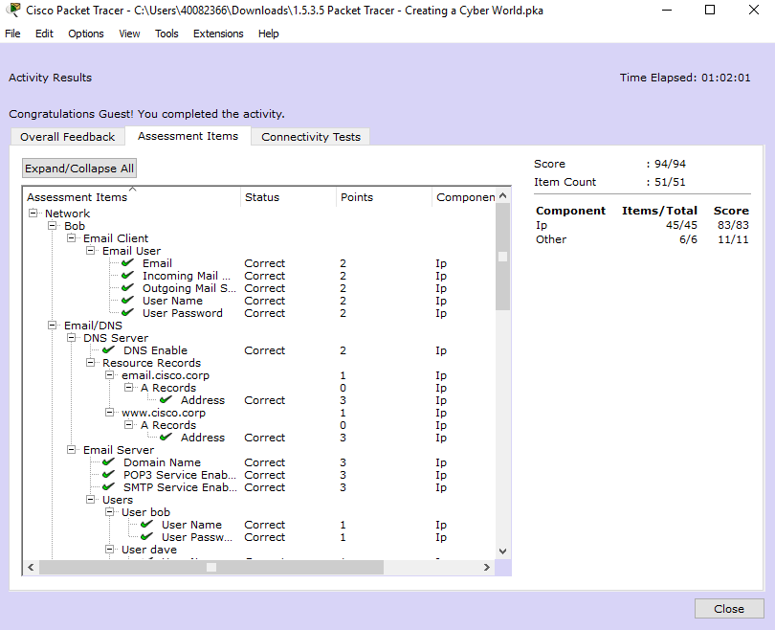

* Why would a user be able to browse to an IP address but not a FQDN?
* The DNS server is not set
* Why is the user able to browse to an FQDN?
* The DNS is not activated so sally is not able to access the website.
* Why does the Email service require both SMTP and POP3 to be activated?
* The email service is not required in the SMTP and POP3 protocols function as they perform sending and receiving emails.